Tijani Ukay Connect v2

- Use google Antigravity for AI dev works - Download the app to desktop
- Create a folder
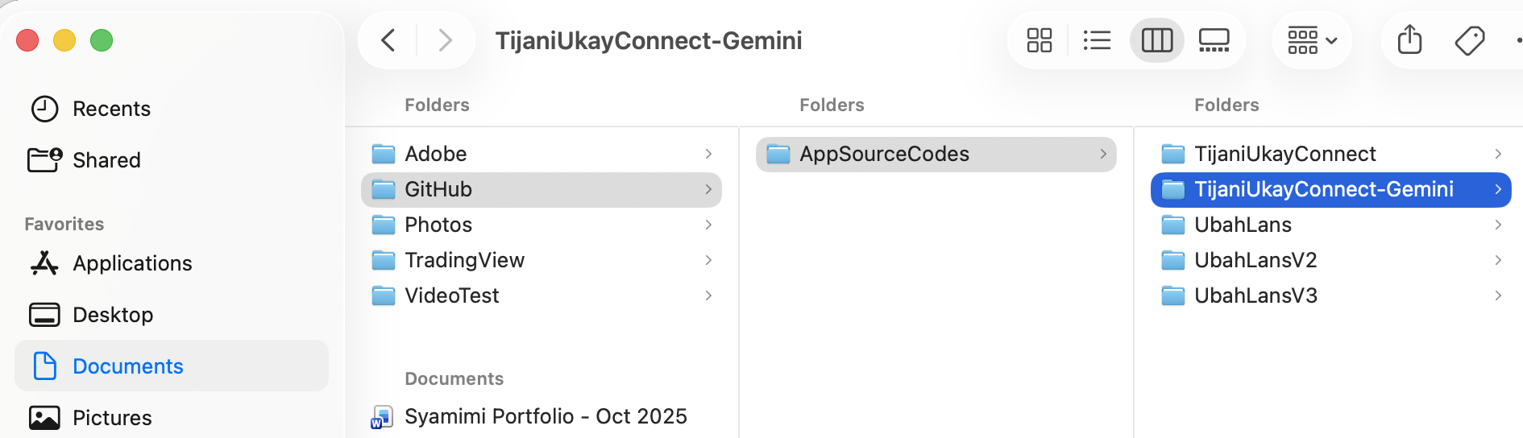
- Open this folder in Antigravity and start AI development
  - Database use is supabase – antigravity will give sql commands to create sql tables, setting security etc
- Key command (from antigravity terminal):
  - npm install (one time only)
  - npm run dev – create local host to test app
  - npm run build – which will create sub-folder ‘dist’ for final deployment. Copy all files/folder under dist to host platform
- Use Supabase settings:
  - 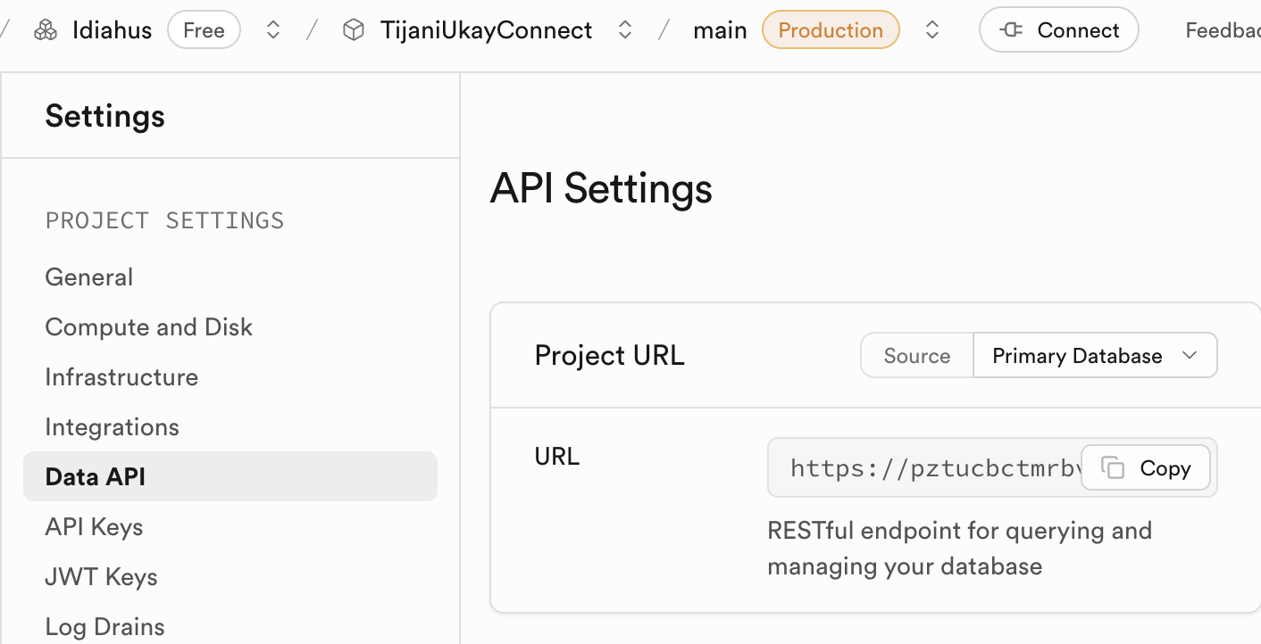
  - 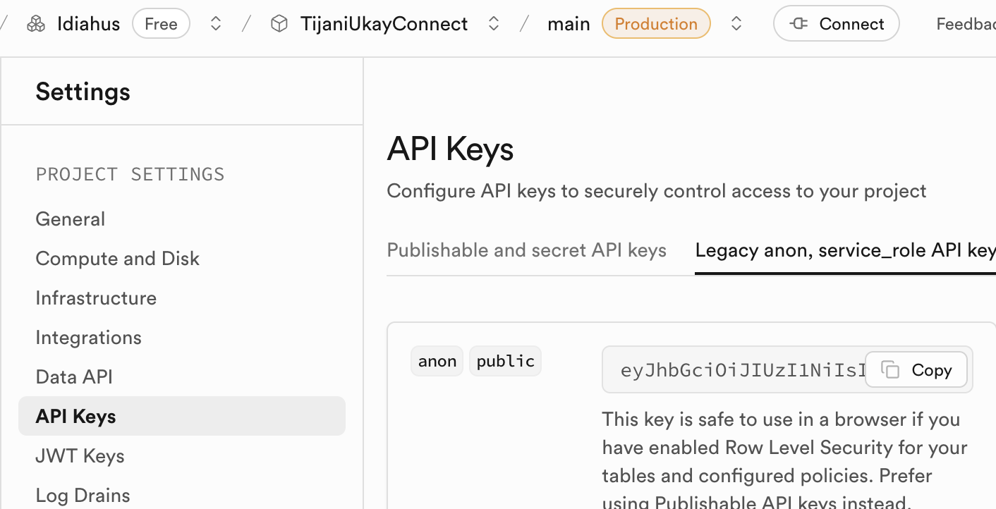
  - 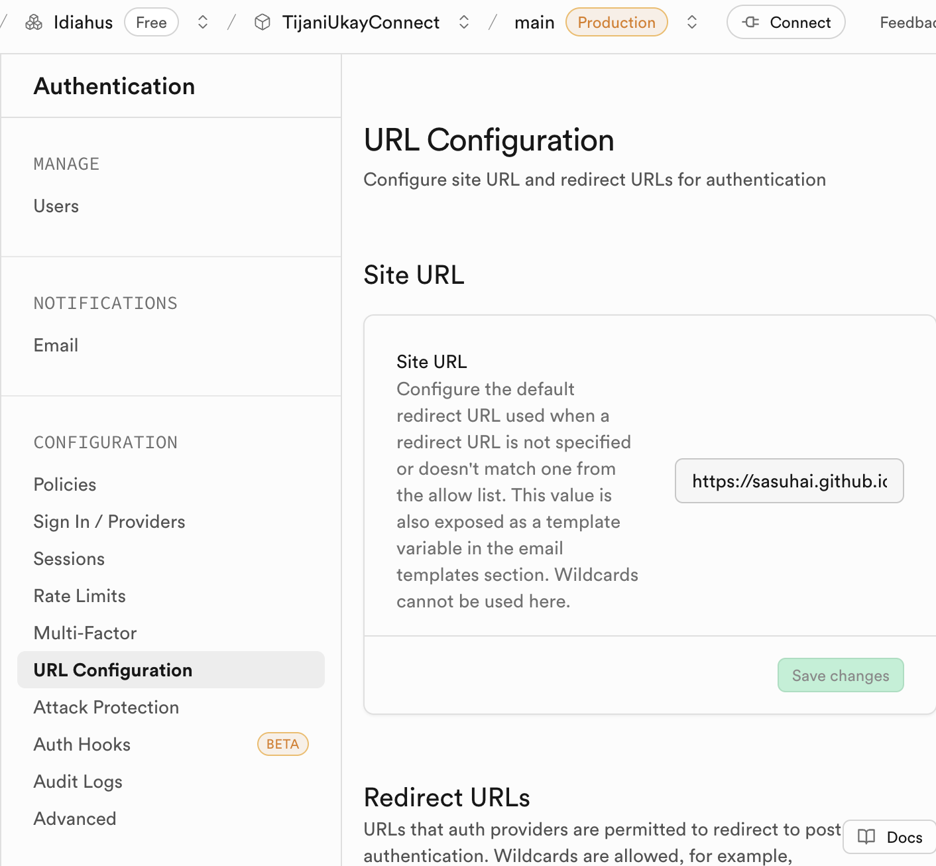
- Use Github desktop and web
  - Create repository on github web and establish pull/push with source codes on computer
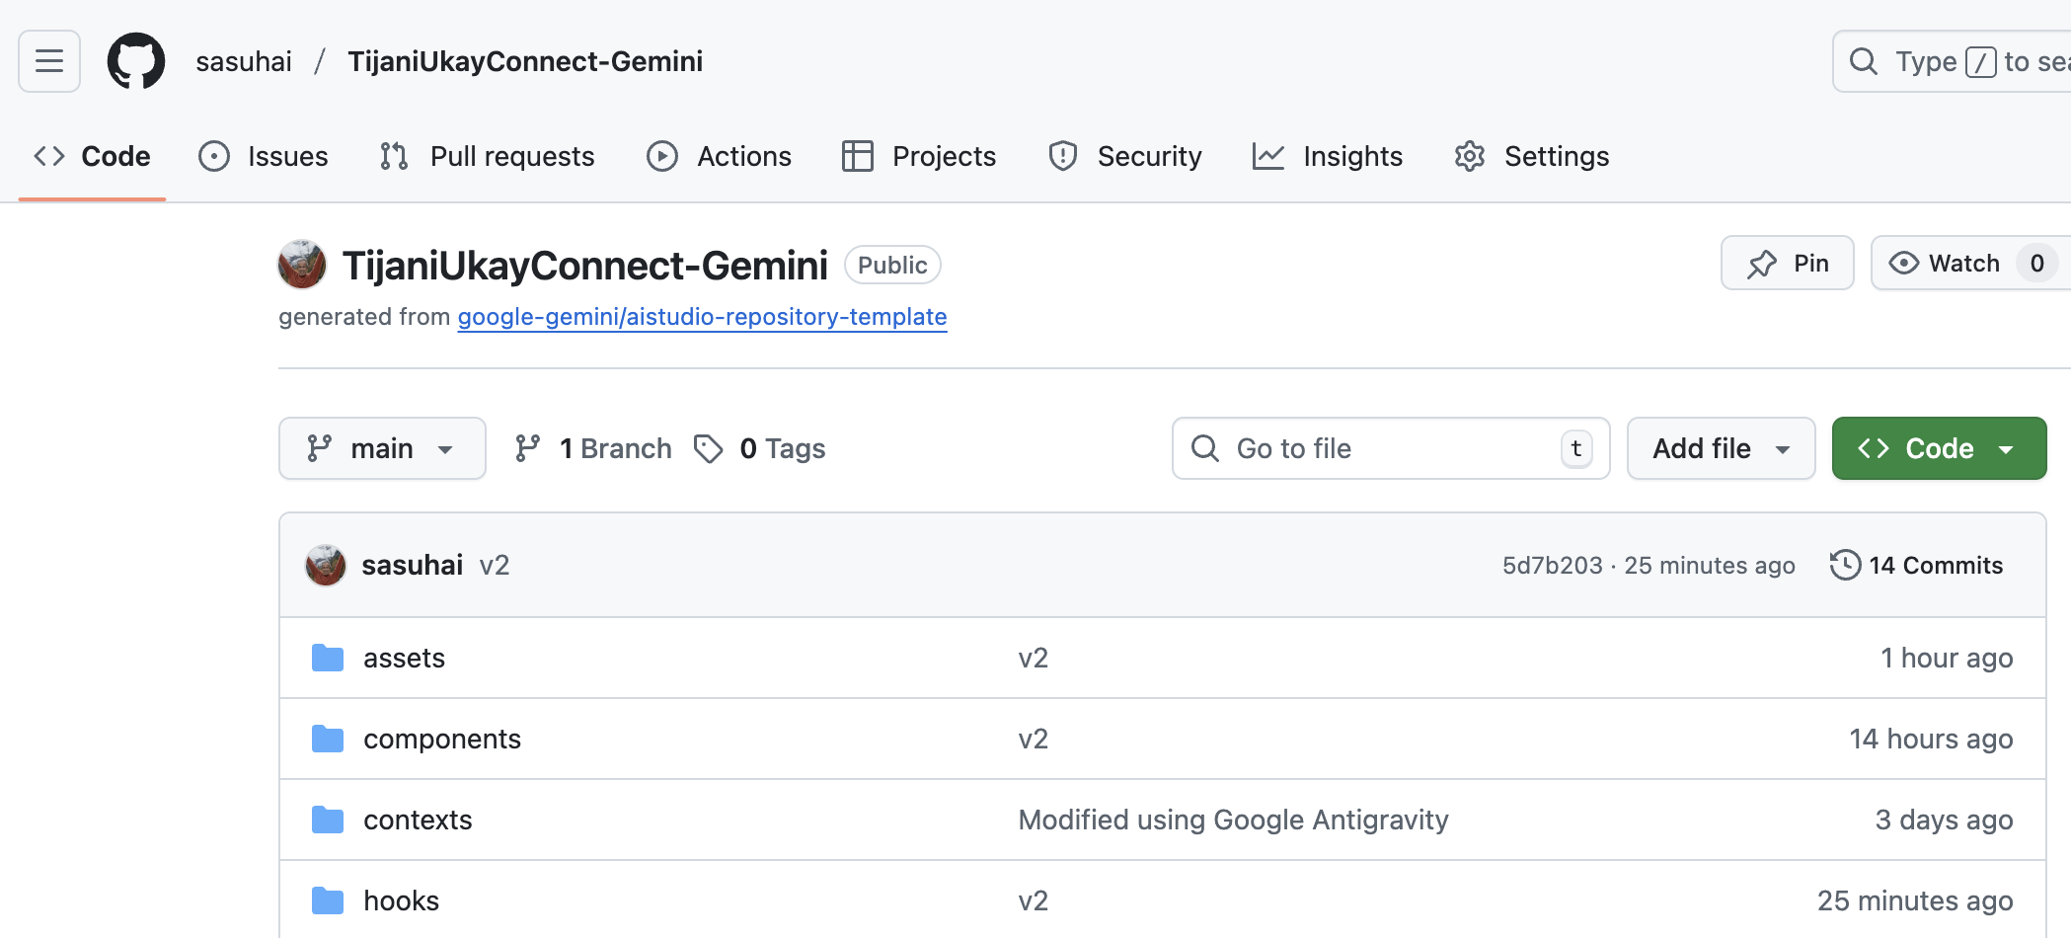
  - Use github desktop to push to github web (source codes)
- Deploy app to github pages
  - Create repository for deployment here – only upload/add files from ‘dist’ folder here – after ‘npm run build’

   